Artificial Intelligence
CSE422
Final Project Report



Title: Academic Success & Dropout Prediction

Date of Submission: 15/05/2025
Group: 9

Group Member:

Ashiqul Alam Iftekher Uddin Rafi
ID: 21301336 ID: 22301549
Section: 13 Section: 13

Department of Computer Science and Engineering
BRAC University
Table of Contents:

Section | Content | Page No
01 | Introduction | 03
02 | Dataset description | 03
03 | Dataset Preprocessing | 08
04 | Feature Scaling | 11
05 | Dataset Splitting | 11
06 | Model Training and testing | 12
07 | Model selection/comparison analysis | 16
08 | Conclusion | 20
09 | References | 20

Introduction
This project aims to predict academic success outcomes for higher education students using machine learning techniques. The motivation behind this project is to identify factors that influence student performance and develop predictive models that can help educational institutions implement early intervention strategies to reduce dropout rates and improve academic outcomes. Academic success is a critical concern in higher education, with dropout rates being a significant challenge for many institutions.

The project utilizes machine learning classification techniques to categorize students into three outcome categories: Dropout, Enrolled, and Graduate based on various demographic, social, economic, and academic features. This approach enables early identification of at-risk students and facilitates timely intervention.

Dataset description
Source :
- Link: https://drive.google.com/file/d/1dbw3qN6lv-N5Wuyf_lC-LmIWTygGT7z7/view
- https://docs.google.com/document/d/1mFM5tGTH1zxTNwbpVEXDsHqYyXYnrApsmsAgHlUzWd8/edit?usp=sharing

Description:
The Academic Success Prediction dataset is designed to support the identification of student academic outcomes in higher education institutions. It enables predictive modeling to determine whether a student will graduate, remain enrolled, or drop out, based on a variety of academic, demographic, and socioeconomic features.
This is a multiclass classification problem, as the target variable Target consists of three distinct categories:
- 0 – Dropout
- 1 – Enrolled
- 2 – Graduate
Each record in the dataset represents an individual student’s academic journey and background. The aim is to train models that can classify students into one of the three outcome categories.
The Target variable is categorical and discrete, with three mutually exclusive classes. Since the task involves assigning each instance to one of these outcome groups, the problem is best approached using supervised classification algorithms.

Data Types and Categories:

The dataset contains approximately 4,424 instances (rows) after preprocessing. Each instance corresponds to a unique student and includes a mix of quantitative and categorical features that reflect academic performance, personal background, and economic indicators.
- Quantitative Features: Continuous numeric values representing measurable academic and economic indicators.
- Categorical Features: Discrete or nominal variables representing demographic and institutional factors.
  - Number of features: The dataset contains 22 numerical features after pre-processing, and 1 categorical target variable.
  - Problem type: classification problem with a categorical target and only numerical features.
  - Number of data points: 4424 instances
  - Feature types: Both quantitative (numerical) and categorical features.

Categorical Features & Description:

- Marital Status (numeric value) :
- Course (numeric value)
- Daytime/evening attendance (numeric value)
- Previous Qualification (numeric value)
- Nationality (numeric value)
- Mother’s qualification (numeric value)
- Fathers qualification (numeric value)
- Mother’s occupation (numeric value)
- Fathers occupation (numeric value)
- Displaced (numeric value)
- Education special needs (numeric value)
- Debtor (numeric value)
- Tution fees up to date (numeric value)
- Gender (numeric value)
- Scholarship holder (numeric value)
- International (numeric value)
- Target (Label: Dropout,Graduate,Enrolled)

Quantitative Features:
- Previous qualification (grade) (numeric value)
- Admission grade (numeric value)
- Age of enrollment (numeric value)
- Unemployment rate (numeric value)
- Inflation rate (numeric value)
- GDP (numeric value)

Feature Descriptions
- Marital status
Type: Categorical (Integer)
Description: Indicates the student's marital status.
- Application mode
Type: Categorical (Integer)
Description: Represents the method through which the student applied to the institution
- Application order
Type: Quantitative (Integer)
Description: Denotes the preference order of the application submitted by the student.
- Course
Type: Categorical (Integer)
Description: Specifies the course or program the student enrolled in.

- Daytime/evening attendance
Type: Categorical (Integer)
Description: Indicates whether the student attends classes during the day or evening.
- Previous qualification
Type: Categorical (Integer)
Description: Represents the type of qualification the student held prior to enrollment.
- Previous qualification (grade)
Type: Quantitative (Float)
Description: The grade achieved in the student's previous qualification.
- Nacionality
Type: Categorical (Integer)
Description: Denotes the student's nationality.
- Mother's qualification
Type: Categorical (Integer)
Description: Indicates the highest educational qualification attained by the student's mother.
- Father's qualification
Type: Categorical (Integer)
Description: Indicates the highest educational qualification attained by the student's father.
- Mother's occupation
Type: Categorical (Integer)
Description: Represents the occupation of the student's mother.
- Father's occupation
Type: Categorical (Integer)
Description: Represents the occupation of the student's father.
- Displaced
Type: Categorical (Integer)
Description: Indicates whether the student is displaced from their usual residence.
- Educational special needs
Type: Categorical (Integer)
Description: Denotes if the student has any special educational needs.
- Debtor
Type: Categorical (Integer)
Description: Shows if the student has any outstanding debts to the institution.
- Tuition fees up to date
Type: Categorical (Integer)
Description: Indicates whether the student's tuition fees are paid up to date.
- Gender
Type: Categorical (Integer)
Description: Represents the gender of the student.
- Scholarship holder
Type: Categorical (Integer)
Description: Denotes if the student is a recipient of any scholarships.
- Age at enrollment
Type: Quantitative (Integer)
Description: The age of the student at the time of enrollment.
- International
Type: Categorical (Integer)
Description: Indicates whether the student is an international student.
- Unemployment rate
Type: Quantitative (Float)
Description: The unemployment rate at the time of the student's enrollment.
- Inflation rate
Type: Quantitative (Float)
Description: The inflation rate at the time of the student's enrollment.
- GDP
Type: Quantitative (Float)
Description: The Gross Domestic Product at the time of the student's enrollment.
- Target
Type: Categorical (Integer)
Description: The final academic status of the student, encoded as:
0: Dropout
1: Enrolled
2: Graduate

Correlation:
To understand the relationships between different features in the dataset, we performed a correlation analysis using a heatmap visualization.

Correlation matrix Table
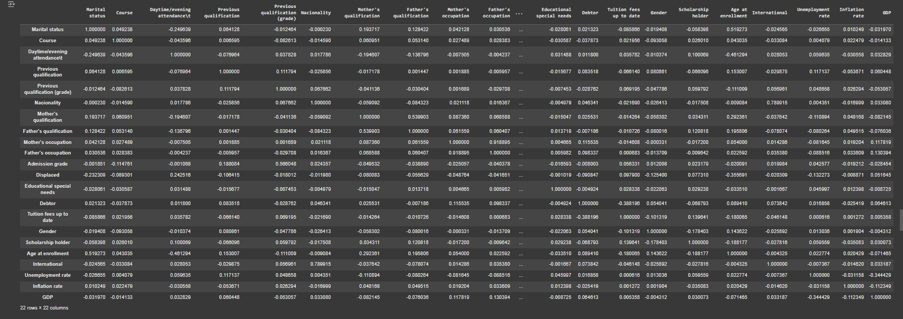

Correlation Heatmap plot
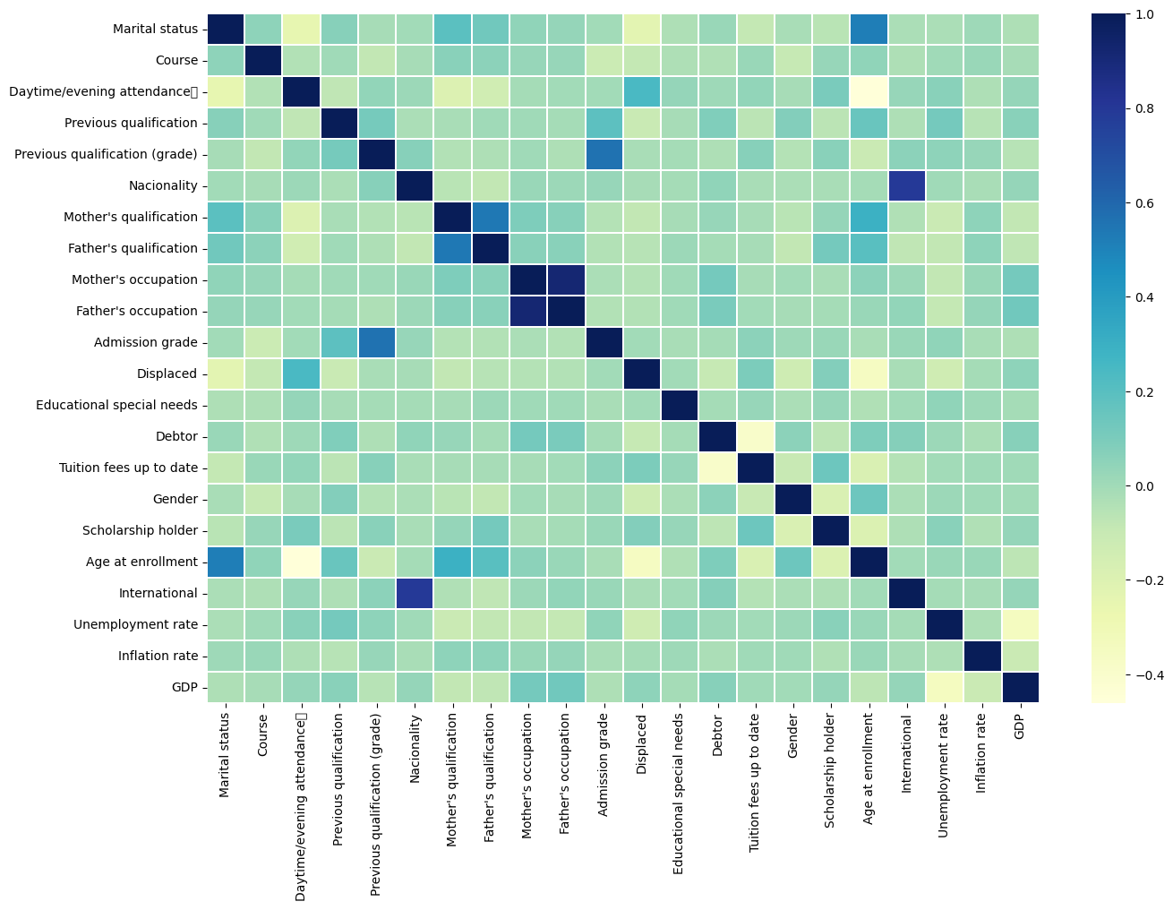

Correlation plot between numerical features and target
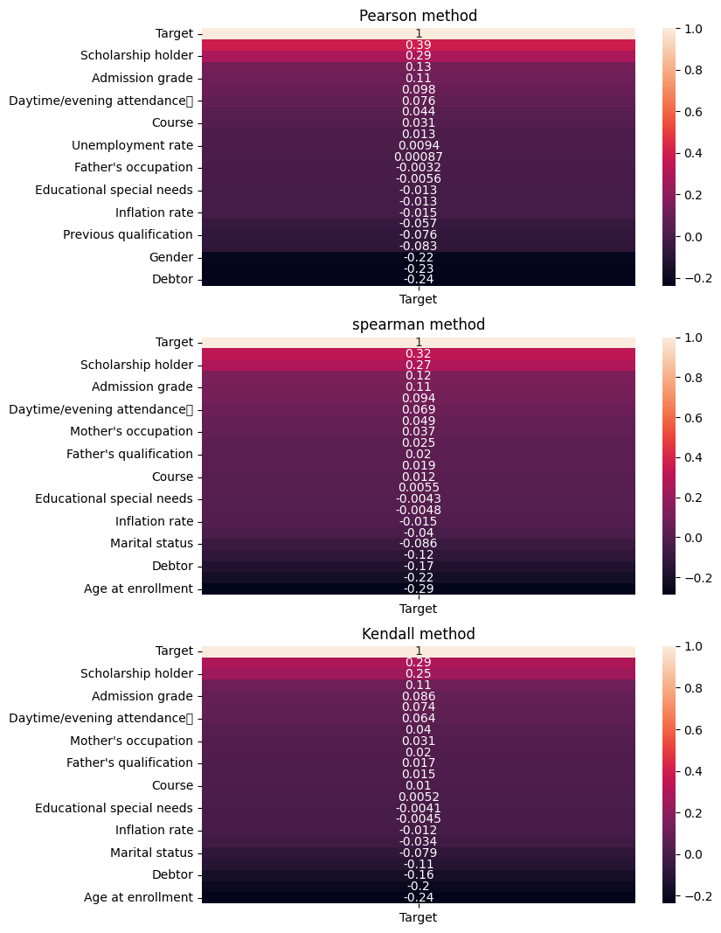

Observations from Correlation Analysis:

Strong Positive Correlations
- Scholarship holder (0.35-0.39): This is consistently the strongest predictor of success. Students with scholarships perform significantly better, which may reflect both their academic abilities (as scholarships are often merit-based) and reduced financial stress.

Moderate Positive Correlations
- Admission grade (0.11): Higher entrance scores predict better academic outcomes, confirming the value of admission standards as predictive tools.
- Daytime/evening attendance (0.07-0.08): Daytime students show slightly better outcomes than evening students, possibly reflecting different time constraints, work responsibilities, or program structures.

Minimal or No Correlation
- Course (0.01-0.04): The specific course chosen has minimal impact on outcomes.
- Mother's occupation (0.03-0.05) and Father's qualification (0.01-0.02): These familial factors show very slight positive correlations, suggesting minimal direct influence.
- Educational special needs (-0.004 to -0.006): Nearly negligible negative correlation, suggesting support systems may be adequately addressing these needs.

Moderate Negative Correlations
- Gender (-0.09 to -0.12): Shows a moderate negative correlation, which might indicate gender disparities in outcomes.
- Previous qualification (-0.01 to -0.07): Slightly negative correlation could suggest that prior academic preparation may not align perfectly with requirements of current programs.
- Inflation rate (-0.01 to -0.04): Limited negative impact of economic conditions.

Strong Negative Correlations
- Debtor status (-0.14 to -0.21): Students with outstanding debts perform notably worse, highlighting how financial strain impacts academic success.
- Age at enrollment (-0.17 to -0.23): Older students tend to have poorer outcomes, possibly reflecting challenges in returning to education or balancing multiple responsibilities.

Inter-Variable Correlations
The heatmap (Image 1) reveals several important relationships between predictor variables:
- Family background clusters: Strong correlations between:
  - Mother's qualification and Father's qualification (0.6+)
  - Parents' qualifications and their occupations (0.4-0.5)
  - These suggest socioeconomic factors tend to cluster together
- Economic indicators: GDP, inflation rate, and unemployment rate show moderate correlations with each other (0.2-0.4), as expected for macroeconomic measures.
- Educational background: Previous qualification and its grade show strong correlation (0.6+), validating internal consistency of academic performance measures.
- Nationality and International status: Strong correlation (0.8+), which is expected as these variables capture related information.
The consistency across all three correlation methods (Pearson, Spearman, and Kendall) strengthens confidence in these findings:
- Pearson measures linear relationships and assumes normal distribution
- Spearman captures monotonic relationships without requiring linearity
- Kendall often provides more robust results with ordinal data and outliers
The similar patterns across all three methods suggest these relationships are robust regardless of distributional assumptions.

- Financial support interventions: The strong positive correlation with scholarship status and negative correlation with debtor status suggests targeted financial aid could significantly improve outcomes.
- Age-appropriate support: Additional resources for older students could help address their specific challenges.
- Admission criteria validation: The moderate correlation with admission grades validates their use in selection processes.
- Socioeconomic considerations: The clustering of family background variables suggests that socioeconomic factors operate as a system rather than as isolated variables.

Imbalanced Dataset Analysis
The distribution of the target classes shows significant imbalance:
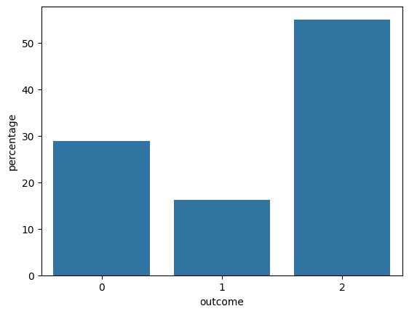
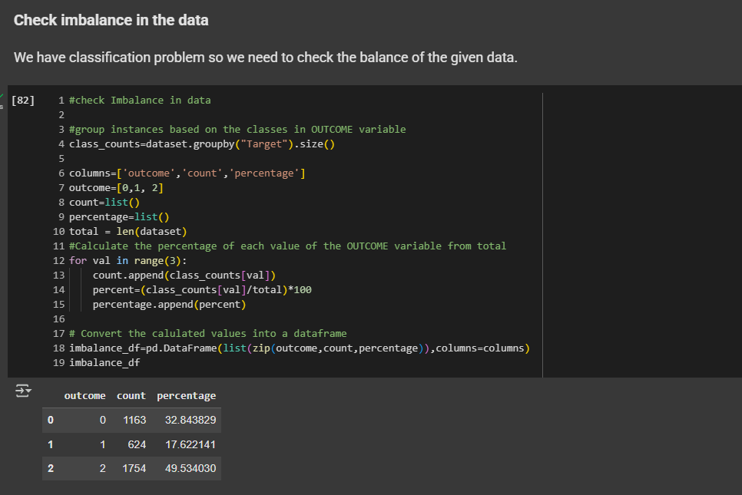

Distribution of target classes:

  - Graduate: 49.534% (1163 instances)
  - Dropout: 32.843% (1754 instances)
  - Enrolled: 17.622% (624 instances)

This imbalance indicates that Graduates represent the majority class, while Enrolled students are the minority class. This class imbalance is important to consider during model training and evaluation.

Exploratory Data Analysis:

Density plot of numerical features:
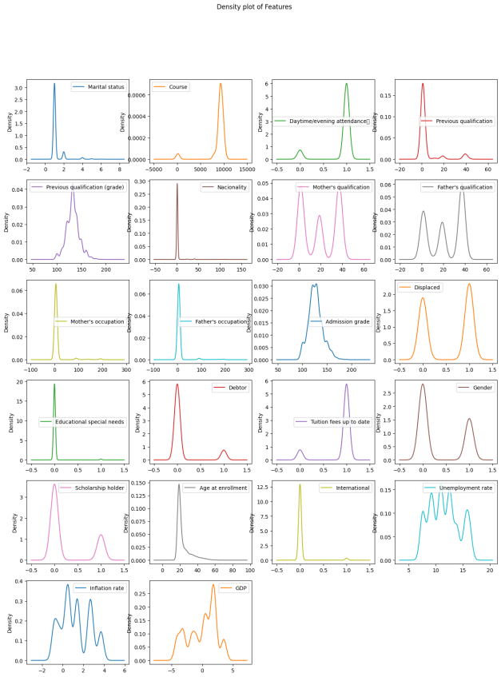

Distribution of Numerical Features

The histograms of numerical features reveal several insights:

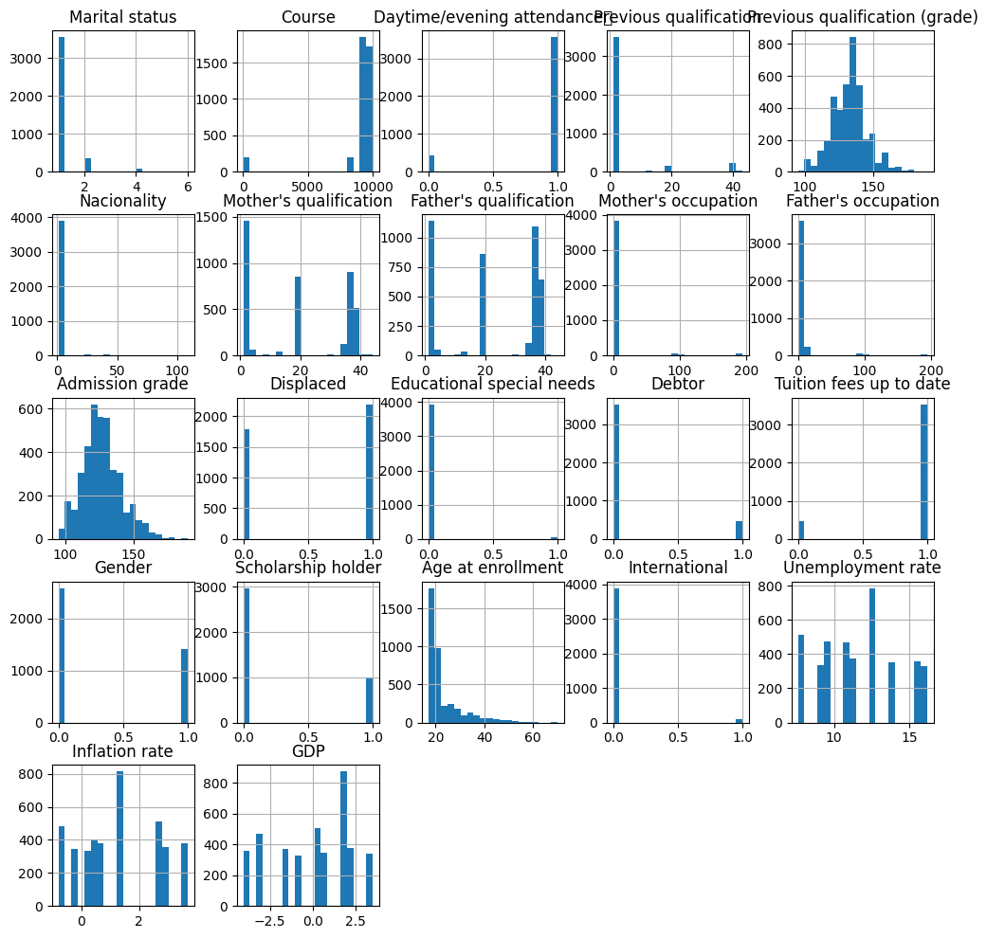

Key observations:

  - Age at enrollment shows a right-skewed distribution with most students enrolling between 18-23 years
  - Previous qualification and admission grades display approximately normal distributions
  - The number of curricular units in both semesters shows bimodal distributions, indicating different patterns of course load among students.
  - Economic indicators (GDP, inflation rate, unemployment rate) show variations due to different enrollment years

Box Plots for Outlier Detection

Box plots were used to identify outliers in numerical features. Several features contain outliers, particularly:

  - Age at enrollment (some students significantly older than average)
  - Previous qualification (some exceptionally high or low grades)
  - Economic indicators (reflecting economic fluctuations)

These outliers were handled during the preprocessing stage to ensure they didn't adversely affect model performance.
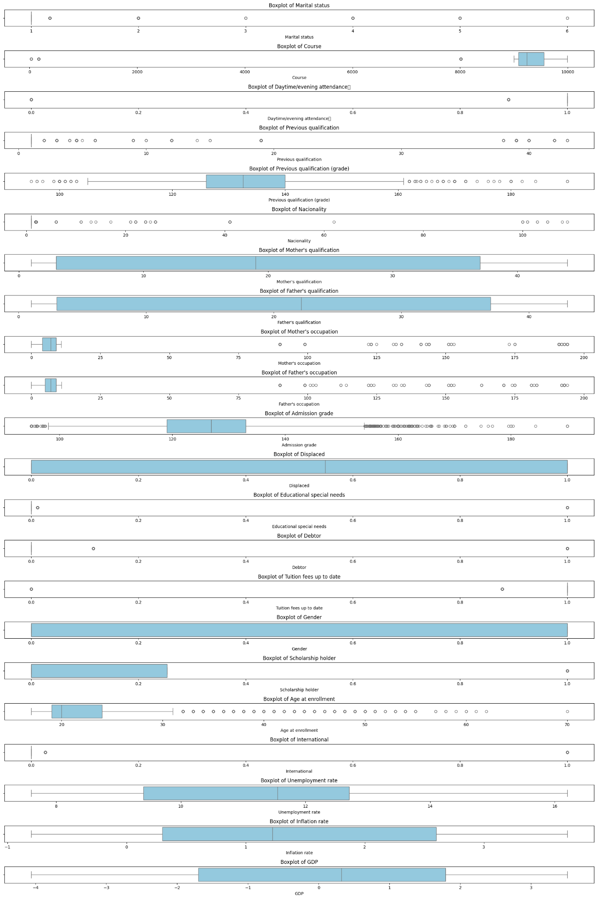
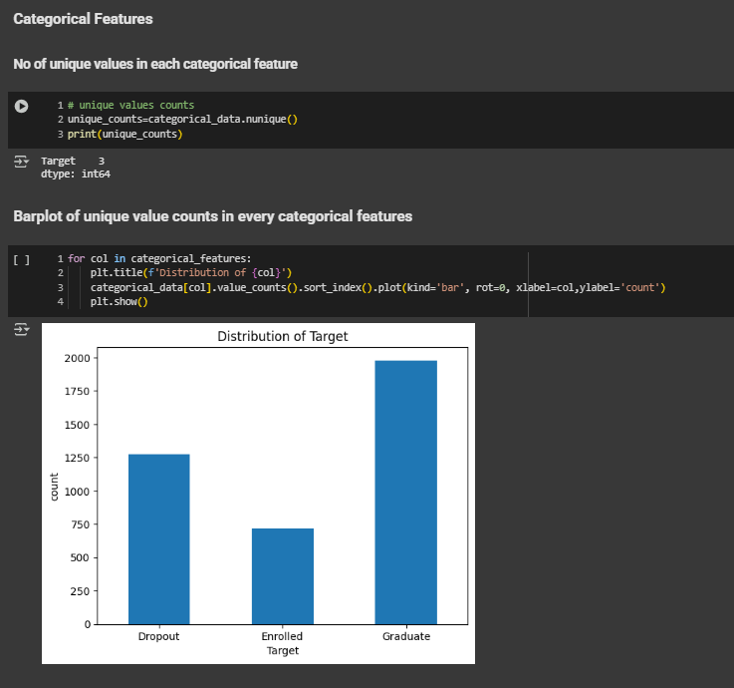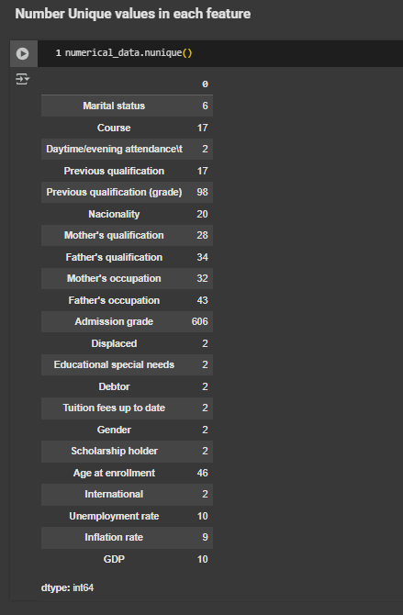

Dataset Preprocessing

Data Cleaning and Handling Missing Values

Handling Null Values:

The initial dataset contained several issues that needed to be addressed. The process included:
- Removing irrelevant columns ('Unnamed: 25', 'Unnamed: 26', 'Application order', 'Application mode')
- Dropping rows with significant missing data, with >= 450 rows

For any numeric column with a high number of missing values (450 or more), all rows containing null values in that column are completely removed from the dataset to avoid unreliable imputations. For columns with fewer missing values, the missing entries are filled using the mean of the respective column. This approach ensures that highly incomplete features do not skew the model, while moderately incomplete ones are preserved through imputation, maintaining as much data as possible without compromising quality. We are ensuring only 10% of the data is compromised. For the target, we are dropping the rows with null values and only using the above approach for the features.

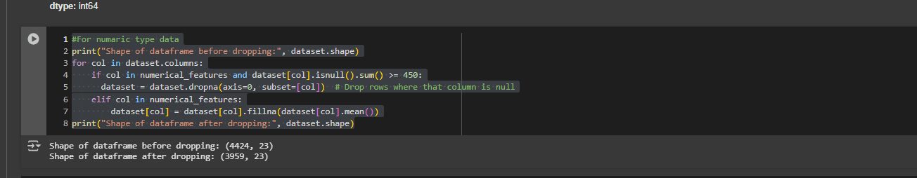

Feature scaling
To ensure all features contribute equally to the model training process, the numerical features were standardized using StandardScaler.This technique transforms the features so that they have a mean of zero and a standard deviation of one, ensuring that all attributes contribute equally to the learning process. Without scaling, models like K-Nearest Neighbors and Neural Networks can be biased toward features with larger numeric ranges. The dataset was first split into training and testing sets, and the scaler was fitted only on the training data to prevent data leakage. The same transformation was then applied to the test data to maintain consistency and improve the model performance.
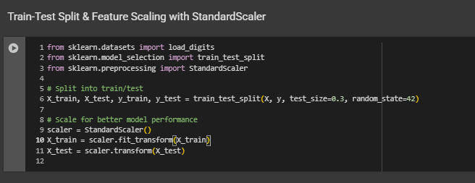

Dataset Splitting

The train_test_split technique divides the dataset into 70% for training and 30% for testing. This gives a trustworthy indicator of the model's accuracy and generalization capacity through verifying it properly learns patterns from the training set and assesses performance on unknown data in the testing set.

Model Training and testing

Overall Accuracy Comparison:
- Gaussian Naive Bayes: 56% (highest)
- KNN: 55%
- Neural Network: 51%
While these differences are modest, they reveal important patterns in predictive capability.

Detailed Model Analysis

1. Gaussian Naive Bayes:
--- Gaussian Naive Bayes Classification Report ---
precision recall f1-score support

Dropout 0.59 0.47 0.52 364
Enrolled 0.22 0.08 0.12 184
Graduate 0.57 0.78 0.66 515

accuracy 0.56 1063
macro avg 0.46 0.45 0.43 1063
weighted avg 0.52 0.56 0.52 1063

- Strengths:
Best overall accuracy (56%)
Strongest at identifying Graduates (78% recall)
Best AUC for Dropout (0.74) and Graduate (0.72) classes
- Weaknesses:
Extremely poor at identifying Enrolled students (8% recall)
Tends to over-classify students as Graduates (403 predicted vs 515 actual)
- Key insight: The confusion matrix shows it classified 131 Enrolled students as Graduates, suggesting it struggles to distinguish between these categories.
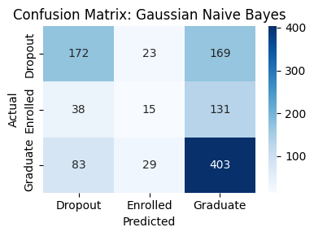

2. KNN Model:
--- KNN Classification Report ---
precision recall f1-score support

Dropout 0.55 0.58 0.57 364
Enrolled 0.26 0.19 0.22 184
Graduate 0.62 0.66 0.64 515

accuracy 0.55 1063
macro avg 0.48 0.48 0.48 1063
weighted avg 0.54 0.55 0.54 1063
- Strengths:
Good balance between precision and recall across classes
Second-best overall accuracy (55%)
- Reasonable AUC scores (0.73 for Dropout, 0.71 for Graduate)
- Weaknesses:
Poor performance on Enrolled class (19% recall)
Less discriminative than Naive Bayes for Graduate identification
- Key insight: More conservative in predicting Graduates than Naive Bayes, resulting in better precision.
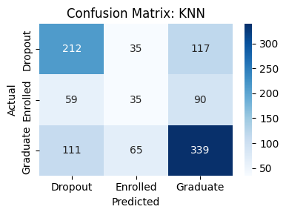

3. Neural Network:
--- Neural Network Classification Report ---
precision recall f1-score support

Dropout 0.53 0.52 0.52 364
Enrolled 0.21 0.22 0.21 184
Graduate 0.61 0.60 0.61 515

accuracy 0.51 1063
macro avg 0.45 0.45 0.45 1063
weighted avg 0.51 0.51 0.51 1063
- Strengths:
Most balanced performance across all three classes
Best at identifying Enrolled students (22% recall)
Good discriminative ability for Dropout class (AUC=0.72)
- Weaknesses:
Lowest overall accuracy (51%)
Less precise than other models for Graduate prediction
- Key insight: The confusion matrix shows more balanced predictions but at the cost of overall accuracy.
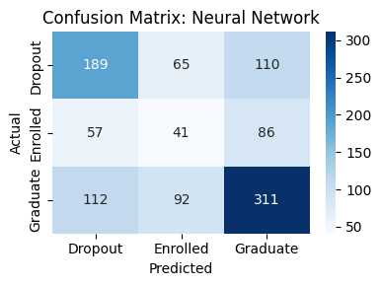

Class-Specific Analysis

Graduate Class (Largest class - 515 students)
- Best model: Gaussian Naive Bayes (F1=0.66, Recall=0.78)
- All models perform reasonably well on this majority class
- Naive Bayes shows strong tendency to classify students as Graduates

Dropout Class (364 students)
- Best model: KNN (F1=0.57, Recall=0.58)
- All models show similar capability in identifying potential dropouts
- ROC curves show good discriminative ability (AUCs 0.72-0.74)

Enrolled Class (Smallest class - 184 students)
- Best model: Neural Network (F1=0.21, Recall=0.22)
- All models struggle significantly with this minority class
- Poor AUC scores (0.55-0.59) indicate limited discriminative ability
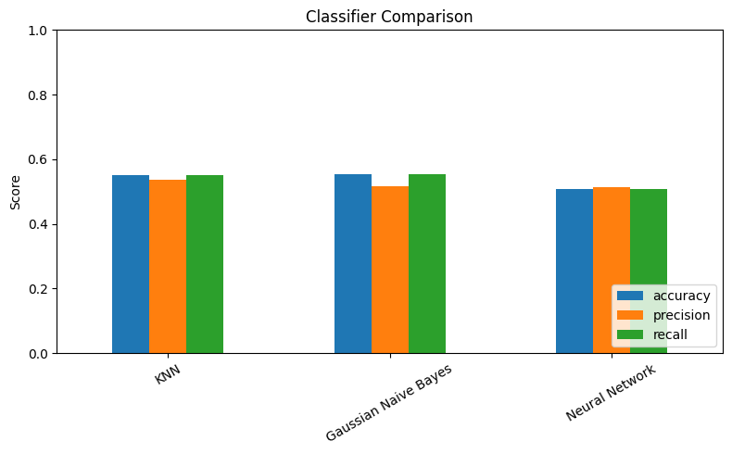

ROC Curve Analysis
The ROC curves provide additional insight:
- Dropout prediction: All models perform similarly well (AUCs 0.72-0.74)
- Graduate prediction: Naive Bayes outperforms (AUC=0.72)
- Enrolled prediction: All models struggle (AUCs 0.55-0.59)
The curves for Enrolled class hover much closer to the diagonal "chance" line, confirming the challenge in predicting this outcome.
For dropout prediction: Any model performs adequately, with slight preference for Naive Bayes
For graduate prediction: Gaussian Naive Bayes offers highest recall
For balanced predictions: Neural Network provides most consistent performance across classes
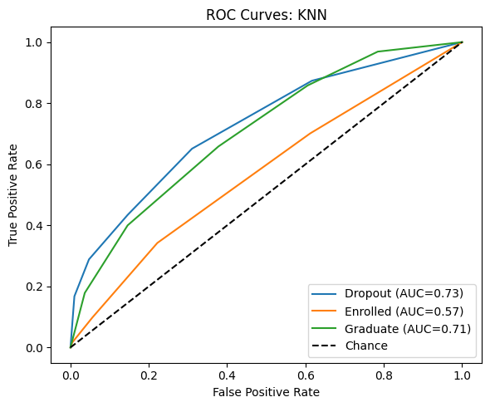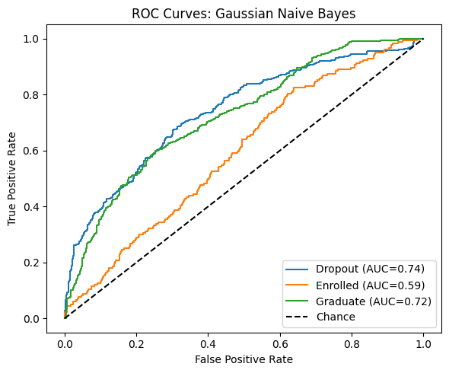
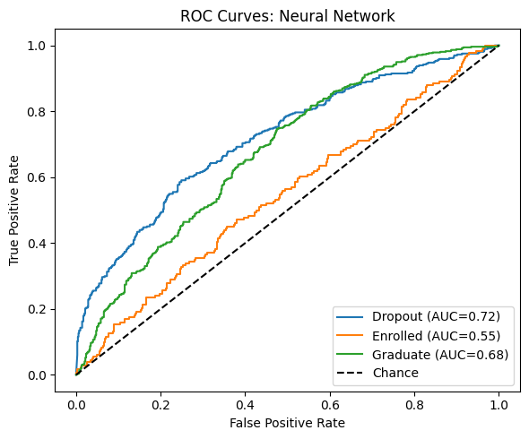

Conclusion
Our analysis of academic outcome prediction models provides valuable insights into factors influencing student success in higher education. The Gaussian Naive Bayes model achieved the highest overall accuracy (56%), demonstrating particular strength in identifying Graduate students (78% recall) but struggling with the Enrolled class (8% recall). Meanwhile, KNN showed good balance between precision and recall across classes (55% accuracy), and the Neural Network offered the most balanced performance despite lower overall accuracy (51%), notably performing best at identifying the challenging Enrolled class (22% recall). These performance differences largely stem from the significant class imbalance in our dataset (Graduate: 49.5%, Dropout: 32.8%, Enrolled: 17.6%), which naturally biases models toward better performance on majority classes. Our correlation analysis revealed that financial factors (scholarship holder status: +0.35-0.39; debtor status: -0.14 to -0.21) and age at enrollment (-0.17 to -0.23) are the strongest predictors of academic outcomes, suggesting that socioeconomic support and age-appropriate resources could be crucial intervention points for educational institutions. The temporal and transitional nature of the "Enrolled" status likely contributes to the difficulty in its prediction compared to the terminal states of Dropout and Graduate. Throughout this project, we faced several challenges including data quality issues requiring careful handling of missing values, the complexity of selecting relevant features from the 23 available attributes, balancing model selection trade-offs between overall accuracy and class-specific performance, and interpreting the complex interrelationships between socioeconomic factors. These findings highlight the potential of machine learning in educational analytics while emphasizing the need for class-balancing techniques and targeted feature engineering in future work to improve prediction accuracy, particularly for underrepresented classes.

